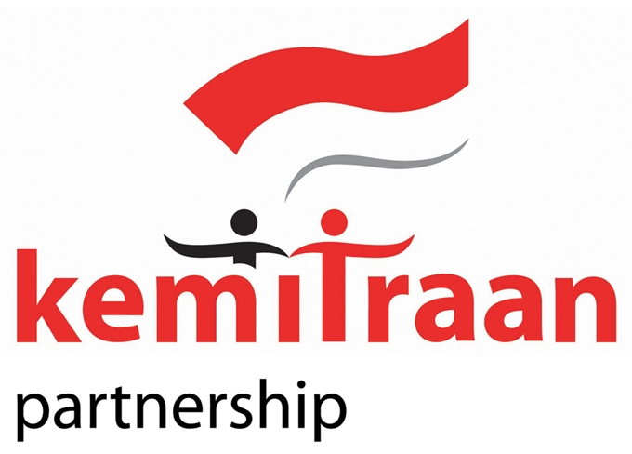 | Partnership for Governance Reform in Indonesia

I. Position Information
Post Title | : | Project Manager of Building and Empowering Civil Society Actors to Protect Freedom of Expression (BE SAFE) Program
Duration of Contract | : | 12 months with the possibility of extension
Supervisor | : | Program Director of Law, Anti-Corruption and Human Right

II. Organizational Context
The BE SAFE (Building and Empowering Civil Society Actors to Protect Freedom of Expression) Program is KEMITRAAN’s 27 months program aims to strengthen legal protection of FoE in Indonesia through three means: (1) enhancing CSOs' advocacy efforts to improve legal frameworks and enforcement for FoE protection; (2) strengthening legal aid lawyers' ability to advocate and litigate FoE cases; and (3) raising public awareness of the threats posed by anti-FoE laws. Key target groups are legal aid lawyers, NGO activists, journalists, and university students, with benefits also extending to government bodies like the Attorney General's Office, the Supreme Court, and the parliament.

In order to run this program, KEMITRAAN is looking for Project Manager. Under the guidance and direct supervision of the Program Director of DJLAHR, he/she is responsible for the implementation of projects and at the same time shall contribute in analyzing trends related to governance reform on relevant areas under the portfolio of the Program Manager and lead consultations with multiple stakeholders, formulation of program and projects, management, monitoring and evaluation of program and project activities within his/her portfolio.

III. Functions / Key Results Expected
Summary of Key Functions:
- Programmatic strategic direction and operation
- Project design and formulation
- Project management and implementation
- Strategic partnership and networking
The Project manager will perform the following key tasks:
- Lead and manage the entire project cycle within the framework and available budget.
- Develop and implement (coordinate with PME unit and MEL officer) project monitoring and evaluation system to ensure regular information on project achievements and progress against output indicators and project objectives are achieved and the impact of the project can be assessed,
- Following and complying to all KEMITRAAN’s policies, financial management systems, and budget monitoring.
- Examine project budgets and finances on a regular basis (monthly or quarterly) and discuss them with the manager of finance regarding financial reporting problems, mistakes, trends, late payments, overdue promises, and other related matters.
- Prepare and submit all project reports in a timely manner
- Develop, agree and maintain assignment descriptions to all project staffs, with clear information/guidance on tasks and responsibilities of each staff
- Build and maintain positive working relationships with partners government, development partners and other institutions involved in the project ensuring good representation on behalf of the institution.
- Carry out all areas of responsibility in a professional and enhance the reputation of the project and organization (KEMITRAAN).
- Provide assistance to the Program Director (DJLAHR) in efforts to program development within the scope of the DJLAHR and mobilization of the program pipeline potential with development partners
- Other work that related to the success of program and organization.
IV. Competencies
Corporate Responsibility & teamwork:
- Serves and promotes the vision, mission, values, and strategic goals of the Partnership
- Demonstrates integrity by modeling professional values and ethical standards
- Displays cultural, gender, religion, race, nationality and age sensitivity and adaptability
- Plans, prioritizes, and delivers tasks on time
- Participates effectively in a team-based, information-sharing environment, collaborating and cooperating with others

People Skills:
- Sets clear performance goals and standards; executes responsibilities accordingly

Partnering & Networking:
- Seeks and applies knowledge, information, and best practices from within and outside the KEMITRAAN
- Good networks with civil society (particularly legal aids) and government (particularly in legal sector)

Results-Orientation:
- Plans and produces quality results to meet established goals
- Innovation & Judgment
- Contributes creative, practical ideas and approaches to deal with challenging situations Strives for quality client-centered services (internal/external)

Communication:
- Demonstrates effective written and oral communication skills
- Demonstrates good negotiations skills

Job Knowledge & Expertise
- Executes day-to-day tasks systematically & efficiently
- Uses Information Technology effectively as a tool and resource
- Familiar with data warehouse and its maintenance
- Is motivated & demonstrates a capacity to pursue personal development & learn

VI. Recruitment Qualifications
Education and skills: |  |  | Minimum a Bachelor degree on relevant fields (e.g law, public policy, politic) with specialization in human rights, criminal justice system, and/or good governance and civil society organizations in Indonesia.  Strong skills in civil society oversight, public education campaigns, policy analysis, report writing, presentation, and good skills in the use of ICT; clear commitment to governance reform.
Experience: |  |  | At least eight years’ experience in program management, facilitation and participatory research, five years of experience in project management at mid to senior level; five years of specialized experience working with CSOs and/or government agencies; Wide network on human rights, environment, natural resources, good governance, bureaucratic reform, and civil society groups/organizations in Indonesia.  Strong understanding of current socio-political conditions with regard to criminal justice, bureaucratic reform, good governance and civil society organizations in Indonesia. Strong skills in civil society oversight, policy analysis, report writing, presentation, and good skills in the use of ICT; clear commitment to governance reform.  Experience working with international donors, especially US-based donors.
Language Requirements: |  |  | Fluency in written and spoken English and Bahasa Indonesia
VII. Signatures- Job Description Certification
Incumbent (if applicable)

Name Signature Date
Supervisor

Name Signature Date
Chief Division/Section

Name Signature Date

