Terms of Reference

I. Position Information
Job code title: Multimedia Officer
Supervisor: Communication Manager

II. Organizational Context
KEMITRAAN (Partnership) is a multi-stakeholder organization established to promote governance reform. It works hand-in-hand with government agencies, civil society organizations, the private sector, and international development partners in Indonesia to bring about reform at both the national and local levels.
Since its establishment, KEMITRAAN has worked to create an enabling environment for reform in which different components of society come together to discuss, advocate and support the implementation of critical elements of Indonesia’s extensive reform agenda. Leaders of KEMITRAAN come from government, including senior ministers, activists from civil society and faith based groups, the business community and the political world including members of parliament from across partisan divides. The capacity to reach out across and among various divides within society uniquely places KEMITRAAN in a position to promote reform and to do so in a peaceful and engaging manner.
KEMITRAAN has been successful in facilitating public policy reform (the formulation of new laws and regulations or the revision / amendment to the laws and regulations), bureaucratic reforms, judicial and democratization reform, anti-corruption laws, national strategies, creating the Governance Index, promoting and facilitating environmental and economic governance.
To improve and promote the work of KEMITRAAN’s, expertise in managing social media on publicizing the success stories and our involvement with the policy makers are to be enhanced. Hence it is important for KEMITRAAN to heighten and implement a robust media strategy to increase its profile and promoting its programs.
Additionally, KEMITRAAN also needs to demonstrate to all stakeholders, government, civil society, the international media, national press, international community including donors, that KEMITRAAN activities are yielding concrete results.
The Multimedia Officer will be recruited to deliver a variety of multimedia content hence the organization is able to promote, engage, and influence its current and potential audiences. Under the guidance and direct supervision of Communication Manager, he/she is expected to contribute in managing KEMITRAAN’s digital outreach, craft compelling messages and design high quality multimedia materials.

III. Functions / Key Results Expected
The ideal applicant for the job will have the exciting opportunity to support our digital presence, assist with design requirements, and generate audience-engaging multimedia material that will help us make an impact with our work.
The Multimedia Officer will combine technical expertise with creative flair to improve social media presence, website user experience, generate visual design work, and collaborate closely with other team members to increase engagement across our digital channels and add new dimensions to our storytelling.
In addition, the Multimedia Officer is expected to be able to manage and prioritize various tasks from different projects at the same time. S/he is also expected to assist the communication unit in levitating the organization’s name publicly.

Responsibilities:
- Produce multimedia content in various formats, including, but not limited to: videos, podcasts, infographics, motion graphics, PowerPoints, image design, social media content.
- Actively generate ideas to develop high quality and creative communications materials to communicate KEMITRAAN’s work and influence target audiences, especially policymakers.
- Assist with KEMITRAAN’s branding style guide.
- Ensure all communications materials are consistent with KEMITRAAN’s branding style guide.
- Document the creative production process and workflow, and note all feedback for future use.
- Assist in developing compelling communications messages for KEMITRAAN digital channels.
- Collaboratively manage KEMITRAAN social media and website
- Manage multimedia resources, including developing and maintaining the photo library – and when appropriate – work with consultants to produce digital content to promote KEMITRAAN.

IV. Impact of Results
Contributing to KEMITRAAN strategy in communication. Especially to KEMITRAAN’s branding positioning as the key driver of governance reform in Indonesia and maximizing its opportunity to secure medium to long term funding.

V. Competencies
Corporate Competencies:

- Demonstrates integrity by modeling professional values and ethical standards
- Promotes the vision, mission, and strategic goals of the Partnership
- Displays cultural, gender, religion, race, nationality and age sensitivity and adaptability

Functional Competencies:

Technical Functions:
- Good ability to conceptualize and develop strategic materials and identify compelling, human and environmental-centered stories for KEMITRAAN campaigns, including press release, interactive social media graphics, and videos.
- Apply visual design best practice principles to the design and development of interactive elements (graphics, videos, animations, interactive simulations, etc.), while maintaining KEMITRAAN branding and graphics standards.
- Strong ability to carry out interviews, make video recordings and take photographs to produce audio-visual materials based on the storytelling technique.
- Strong graphic design, videography and photography experience for digital channel.
- Highly competent in using of a broad range of software applications for multimedia editing and production, including Adobe Suite, Adobe Photoshop, Illustrator, Premier, After Affects, Canva.
- Proficiency in using and understanding analytics of various social media account, such as Instagram, Youtube, Facebook, Twitter, Linkedin
- Basic writing and editing skills in Indonesian and English
- Familiar with Search Engine Optimization techniques
- Familiarity with social media paid ads is a plus
- Passionate about social issues, such as climate change, anti-corruption, gender equality.
Result Orientation
- Organized, with strong planning skills, and the ability to prioritize and work to tight deadlines.
- Ability to manage multiple work streams and numerous stakeholders simultaneously setting and shifting priorities as needed, under the direction of senior leaders.
- Strong organizational skills and attention to detail.
Team Work
- Ability to work both independently and collaboratively to achieve objectives.
- Ability to work effectively in a team-based structure with excellent interpersonal skills that foster productive relationships with colleagues and the organization’s partners.

VI. Recruitment Qualifications
Education: | A Bachelor Degree in Visual Communication, Fine Arts, Media Studies, etc. or equivalent qualification or a proven track record in a similar role.
Experience: | At least 3 years’ work experience in communications, journalism or other multimedia role(s). Preferably have a background/experience working in an NGO before.
Language Requirements: | Fluency in written and spoken English and Bahasa Indonesia
VII. Signatures- Job Description Certification
Incumbent (if applicable)

Name Signature Date
Supervisor
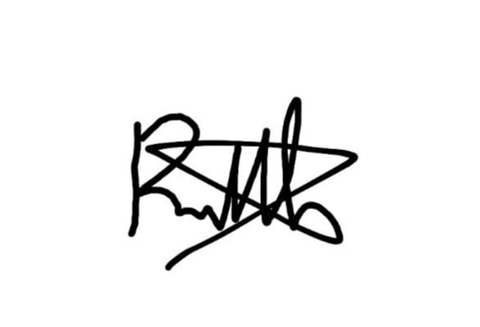
Name:
Rakhmat Nur Hakim Signature Date: 25 November 2024
Chief Division/Section

Name Signature Date

